Problem 01. Determining transition dipole moment and oscillator strength of a molecule experimentally.

As it was shown in lectures 01-05, the efficiency of absorption of light by a molecule depends on the transition dipole moment (TDM, ) for respective transition. In lectures 04-05 we also discussed the connection between optical absorption spectra, which could be measured with standard spectrometers, and quantum-mechanical TDM. This opens a way of deducing the quantum mechanical transition dipole moment from the absorption spectrum measured for a particular molecule.

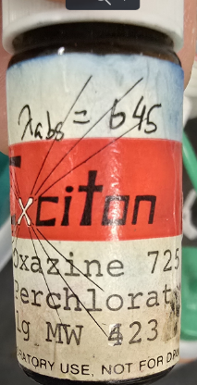
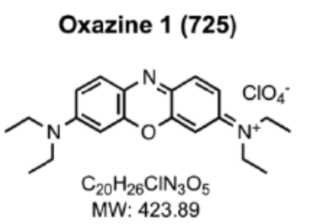
The task is to determine the absorption spectrum of Oxazine 725 (=oxazine 1) molecule (common dye used in dye lasers), 3,7-bis(diethylamino)phenoxazin-5-ium perchlorate. While this molecule is not used by live organisms, it shares general motifs of light-absorbing molecules (π-orbitals, strong HOMO LUMO transition), and is relatively cheap compared to Chlorophyll.
To determine TDM you will perform the following steps:
1. Prepare a sample with a known concentration dissolved in MeOH (methanol)
  - Use a scale to weigh the sample (powder)
  - Determine # of moles in the sample
  - Dilute in MeOH of known volume
  - Calculate concentration
2. Measure its absorption spectrum using a standard absorption spectrometer.
3. Convert spectra to appropriate units (extinction coefficient vs wavenumbers)
4. Use equations introduced in Lecture 4 to calculate oscillator strength and transition dipole moment
Note: the SI unit of dipole moment is C.m (charge * distance), but TDM is usually expressed in Debye; 1 D = 3.34e-30 C.m, or 1D = 0.021 e.nm, where e is the elementary charge. The latter means that 1D is equal to a dipole moment of positive and negative elementary charges separated by 0.021 nm. Since the molecular size of a Chl-like molecule is in the order of 1-2 nm and the electron charge is e, you can get a feel of how large transition dipole moments could be.

Please show your work step by step clearly describing each step.
Note: to calculate (integrate etc.) one can use any programming environment, even Microsoft Excel.

